Goal: Have your first “Hello world” app running on your device using Android Studio

**Install Android Studio:**

1. Download Android Studio from the [Android Studio Website](http://developer.android.com/sdk/index.html).  
   The download comes in two flavors, SDK Tools only and Android Studio Packages. You want to download the Android Studio Package for your operation system.
2. Launch the .exe file you downloaded.
3. Follow the setup wizard to install Android Studio and any necessary SDK tools.

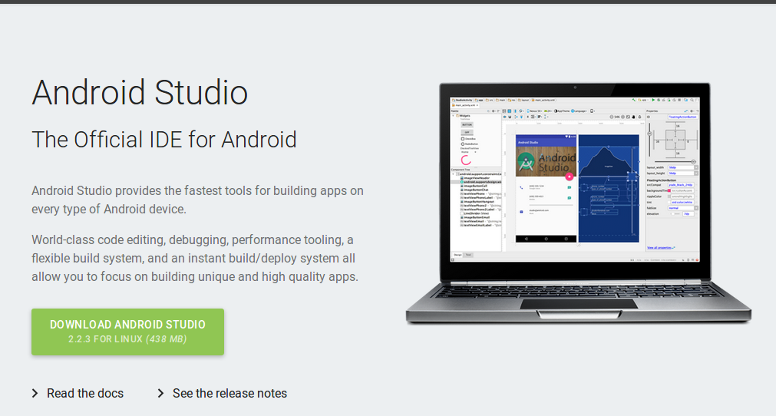

Installation for Windows is simple, just launch the .exe you downloaded. On Max OSX drag and drop Android Studio into the Applications folder.

4. On Windows click next and next up until you have option to chose where to install Studio & SDK  
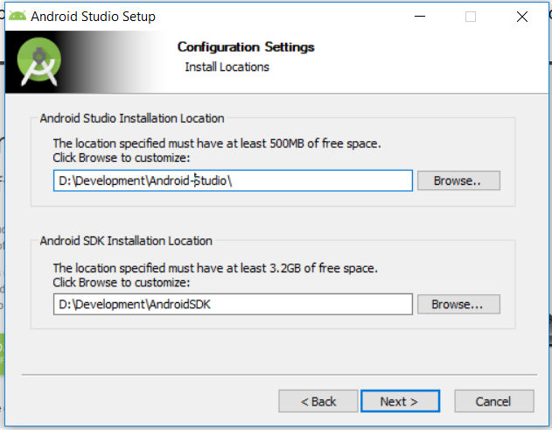

I Suggest to install Studio and SDK in a separate place where you will have all your development tools.

Then wait till installation complete.

Here is full video to install on Windows:  
<https://storage.googleapis.com/androiddevelopers/videos/studio-install-windows.mp4>

Here is full video to install Studio on Mac:

<https://storage.googleapis.com/androiddevelopers/videos/studio-install-mac.mp4>

**Create your project:**

1. In Android Studio, create a new project:
   * If you don't have a project opened, in the **Welcome to Android Studio** window, click **Start a new Android Studio project**.
   * If you have a project opened, select **File > New Project**.
2. In the **New Project** screen, enter the following values:
   * **Application Name**: "My First App"
   * **Company Domain**: "example.com"
3. You might want to change the project location, but leave the other options as they are.
4. Click **Next**.
5. In the **Target Android Devices** screen, keep the default values and click **Next**.
6. If you're curious about how these SDK versions affect your app, read [Supporting Different Platform Versions](https://developer.android.com/training/basics/supporting-devices/platforms.html).
7. In the **Add an Activity to Mobile** screen, select **Empty Activity** and click **Next**.
8. In the **Customize the Activity** screen, keep the default values and click **Finish**.

After some processing, Android Studio opens the IDE. Now take a moment to review the most important files.

**Run Your App**

## **Run on a real device**

Set up your device as follows:

1. Connect your device to your development machine with a USB cable. If you're developing on Windows, you might need to install the appropriate USB driver for your device. For help installing drivers, see the [OEM USB Drivers](https://developer.android.com/studio/run/oem-usb.html) document.
2. Enable **USB debugging** on your device by going to **Settings > Developer options**.
3. **Note:** On Android 4.2 and newer, **Developer options** is hidden by default. To make it available, go to **Settings > About phone** and tap **Build number** seven times. Return to the previous screen to find **Developer options**.

Run the app from Android Studio as follows:

1. In Android Studio, click the **app** module in the **Project** window and then select **Run > Run** (or click **Run**  in the toolbar).
2. In the **Select Deployment Target** window, select your device, and click **OK**.

Android Studio installs the app on your connected device and starts it.

That's "hello world" running on your device!

## **Run on an emulator:**

Before you run your app on an emulator, you need to create an [Android Virtual Device](https://developer.android.com/tools/devices/index.html) (AVD) definition. An AVD definition specifies the characteristics of an Android phone, tablet, Android Wear, or Android TV device that you want to simulate in the Android Emulator.

Create an AVD Definition as follows:

1. Launch the Android Virtual Device Manager by selecting **Tools > Android > AVD Manager**, or by clicking the AVD Manager icon  in the toolbar.
2. In the **Your Virtual Devices** screen, click **Create Virtual Device**.
3. In the **Select Hardware** screen, select a phone device, such as Pixel, and then click **Next**.
4. In the **System Image** screen, click **Download** for one of the recommended system images. Agree to the terms to complete the download.
5. After the download is complete, select the system image from the list and click **Next**.
6. On the next screen, leave all the configuration settings as they are and click **Finish**.
7. Back in the **Your Virtual Devices** screen, select the device you just created and click **Launch this AVD in the emulator** .

While the emulator starts up, close the Android Virtual Device Manager window and return to your project so you can run the app:

1. Once the emulator is booted up, click the **app** module in the **Project** window and then select **Run > Run** (or click **Run**  in the toolbar).
2. In the **Select Deployment Target** window, select the emulator and click **OK**.

Android Studio installs the app on the emulator and starts it.

That's "hello world" running on the emulator!